|  |  |  |
| --- | --- | --- |
| **University of Birmingham**  **School of Engineering**  Department of Mechanical Engineering  **Industrial Automation and Robotics**  **Final Assignment**  **IAR Group No. 10**  **Group Members:** | | |
| First Name | Surname | ID Number |
| James | Perrett | 1672539 |
| Joe | Roxburgh | 1791096 |
| Adlyn | Azizulrahman | 1754466 |
| Andrea | Fani | 1798768 |

Section 1

# Automated Vice Design

## 1.01 Design of automated vice

### Structural and torque requirements

### Motor selection and effective coupling

## 1.02 CAD views of the automated vice annotating key features

### Exploded view

### Bill of materials

# Automated Workcell Design

## Stability Analysis

## Graspability Analysis

## Workcell Layout in FIAB

## Development of optimized sequence plan for automated assembly

## Consideration of required robot operations

### Gripping processes

### Screwing processes

## Flow matrix analysis

## Robot parameters in FIAB environment (reach, work volume, payload)

# Automation Support Systems

## Justification for robot selection

### Size & key selection parameters

#### Storage and organisation gantry robot (Cartesian)

#### Spherical Articulated robot (KUKA)

#### SCARA robot (FANUC SR-6iA)

### Stiffness analysis

#### Storage and organisation gantry robot (Cartesian)

#### Spherical Articulated robot (KUKA)

#### SCARA robot (FANUC SR-6iA)

## 3.02 End-effector design, justification and compliance analysis

## 3.03 Sensors & Systems

### Sensors

### Quality assurance systems (Visual)

### Industrie 4.0 & systems integration (Smart Factory in a Box)

### Flexible fixtures

# Automated Vice Design

## Design of automated vice

For this project a table top vice has been chosen as the most suitable to secure a component of 50kg securely. The following vice design has dimensions 380mm X 140mm X 100mm. The jaws, main body and slide are cast from high quality iron, while the screw and jaw surfaces are cast and quenched steel.

### Structural and torque requirements

The body of the vice is made from iron to for its **structural** properties as it is expected to withstand heavy duty work. Cast and quenched Steel has high tensile strength and corrosion resistance. Hence, it is utilized for the screw and jaw components to increase durability.

The motor is required to have sufficient **torque** to hold a 50kg part. Thus, a frictional force of 490N is required to hold the part. The coefficient of friction for cast steel on steel (dry) is estimated at 0.61 with frictional forces being applied by both jaws.

|  |  |  |
| --- | --- | --- |
|  | $F=ma$ $= 50×9.81=490N$ | **(1)** |
|  | Where, $F$ = Downward force $M$ = mass $a$ = acceleration |  |
|  | $$2f_{f}=490 N ∴ f_{f}=245 N$$ |  |
|  | $f_{f}=μR$, $(R)= \frac{245}{0.6}=408.33 N$ | **(2)** |
|  | Where, $f_{f}$ = Frictional force $R$ = Normal force (Clamping force) $μ$ = coefficient of friction |  |
|  | $$τ=R× r × sin∅= 408.33 × \frac{9.50}{2} × 10^{-3}×sin \left(90\right) =1.94 N m$$ | **(3)** |
|  | Where, $τ$ = Torque $∅$ = angle between F and the lever arm |  |

As the Servo motor will be directly coupled the screw, the **max required torque** is **1.94 N m**

### Motor selection and effective coupling

Our design is going to utilise a **servomotor**. A servomotor provides increased speed, power and accuracy over a stepper motor due to its encoder which provides feedback to the controller to ensure accurate positioning and rotation. The lack of feedback in the stepper motor will lead to the automated vice having to restarted on power-up, and re-calibrated if the clamping process leads to missed steps. The encoder and controller of the servomotor incur greater cost but optimise performance.

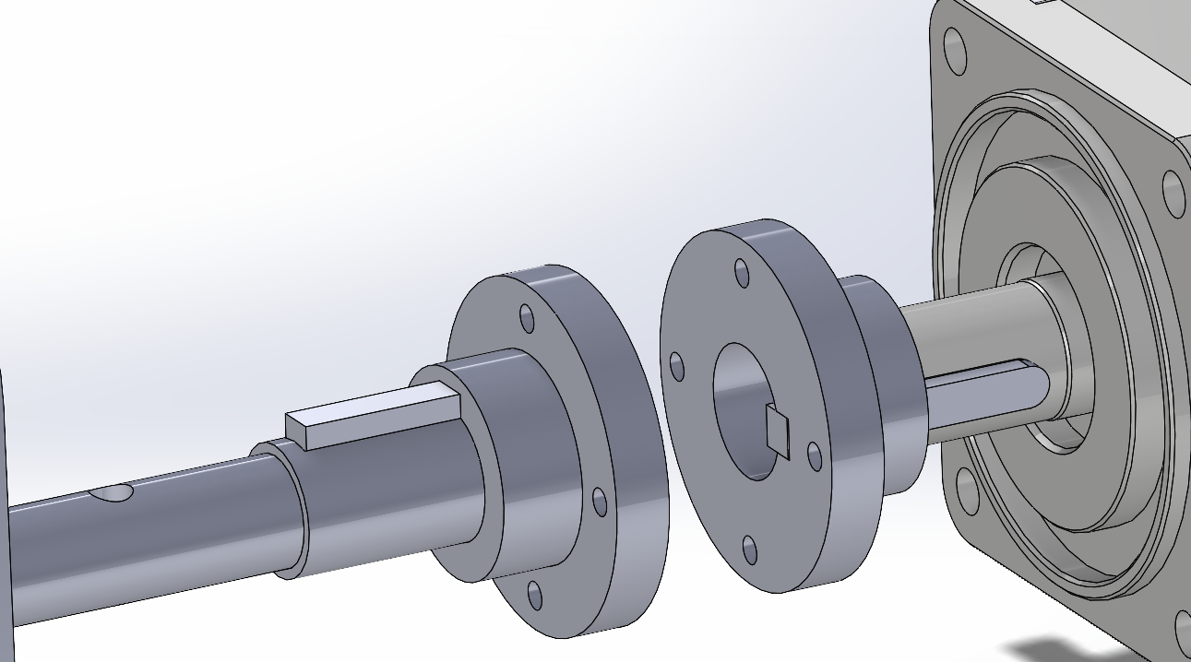The servomotor will be **coupled** using a single keyway. The number of keyways influences shaft’s strength. Higher number of keyways, less shaft strength. However, less keyways allow for shaft’s diameter to be smaller. Hence the design will present **one keyway** as the diameter of the of the shaft2 is only 9.50mm.

Figure 1. **Single** **keyway** coupling shaft and screw

## CAD of the automated vice annotating key features

## 

**C**

**B**

**A**

Figure 2. Side view of automated vice/front view/back view.

1. Gripping locations along sliding jaw – 3 locations have been provided: designed for the spherical articulated robot gripper to handle sliding jaw in process 1, improving graspability.
2. Kinematic Coupling – A Kinematic coupling will allow the static base to rotate if needed.
3. Chamfered & lightweight design – Chamfers and cuts reduce weight and facilitate assembly, including **‘peg in hole’** feature3 of **angle 18.2°** into screw outlet of part 1 to act as a guide for the SCARA robot screw insertion process.

### Exploded view

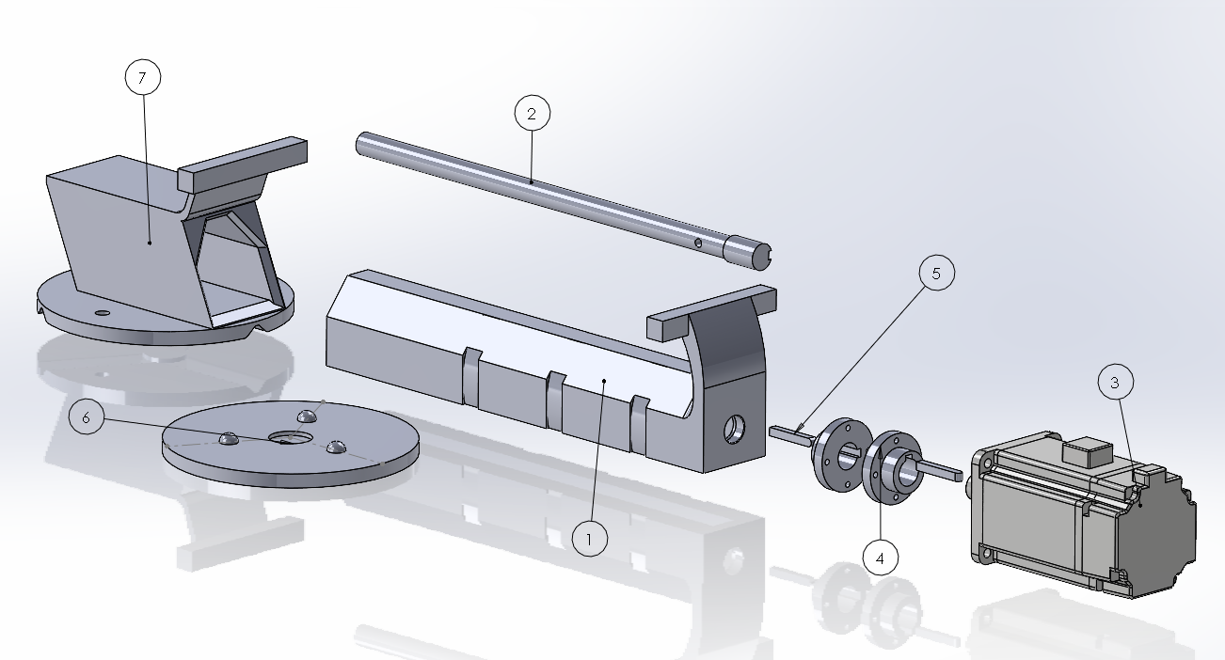 Figure 3. Exploded view of vice

### Bill of materials

*Table 1. Automated vice bill of materials*

|  |  |  |  |
| --- | --- | --- | --- |
| **BALLOON NO.** | **PART NUMBER** | **DESCRIPTION** | **QTY** |
| **1** | **Part 1** | **Slide / Sliding Jaw** | **1** |
| **2** | **Part 2** | **360mm Screw** | **1** |
| **3** | **Part 3** | **Servo Motor 750W** | **1** |
| **4** | **Part 4** | **Flange Coupling** | **2** |
| **5** | **Part 5** | **Key** | **2** |
| **6** | **Part 6** | **Base / Anvil / Static Jaw** | **1** |
| **7** | **Part 7** | **Base kinematic coupling** | **1** |
| **-** | **Part 8** | **Dynamic Jaws** | **2** |
| **-** | **Part 9** | **M4 bolts** | **4** |
| **-** | **Part 10** | **M4 washers** | **8** |
| **-** | **Part 11** | **M4 nuts** | **8** |
| **-** | **Part 12** | **M6 bolts** | **8** |
| **-** | **Part 13** | **M6 washers** | **8** |
| **-** | **Part 14** | **M6 nuts** | **8** |

# Automated Workcell Design

## Stability Analysis

There are three main parts considered in the vice assembly – Base or static jaw, sliding jaw, and 360 mm screw. Thus, there is 3! possible permuted orders. The possible orders are: 1. Base ← Slide ← Screw 2. Base ← Screw ← Slide 3. Screw ← Slide ← Base 4. Screw ← Base ← Slide 5. Slide ← Screw ← Base 6. Slide ← Base ← Screw. Due to part geometry and weight we would expect to see the Base as the static part, to be fixed onto the baseboard. However, all feasible sequences will be considered. Leaving us with three feasible potential sequences: 1. Base ← Slide ← Screw 2. Slide ← Base ← Screw and 3. Slide ← Screw ← Base. Figures 4 show the CAD stability for sequence 1. Base ← Slide ← Screw by measuring the angle between $\overset{→}{P_{b}P_{com}}$ and the horizontal plane.

$S=\left(\begin{matrix}s_{1} \\ s_{2} \\ s_{3}\end{matrix}\right)=\left(\begin{matrix}9 & 7 & 7 \\ 6 & 7 & 7 \\ 6 & 7 & 7\end{matrix}\right)$

Where S1, S2 & S3 refers to the stability of sequence 1, 2 & 3 respectively.

Figure 4. The angle between $\overset{→}{P_{b}P_{com}}$ and the horizontal plane (For Sequence 1)

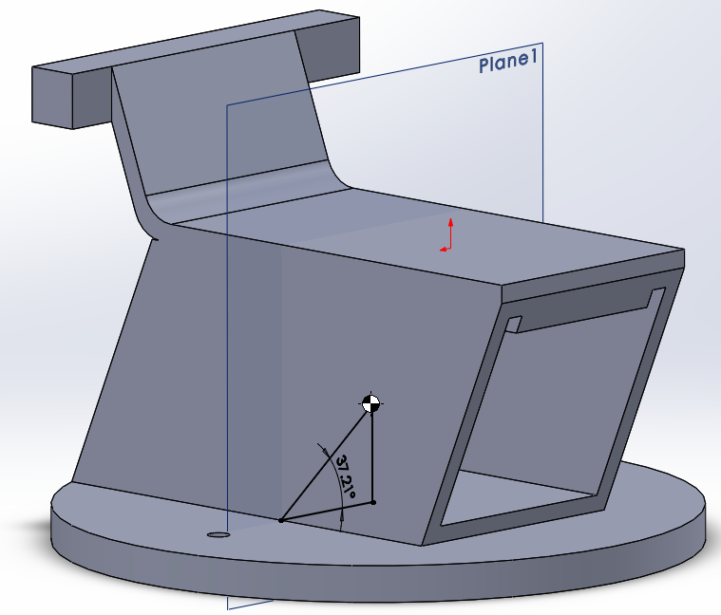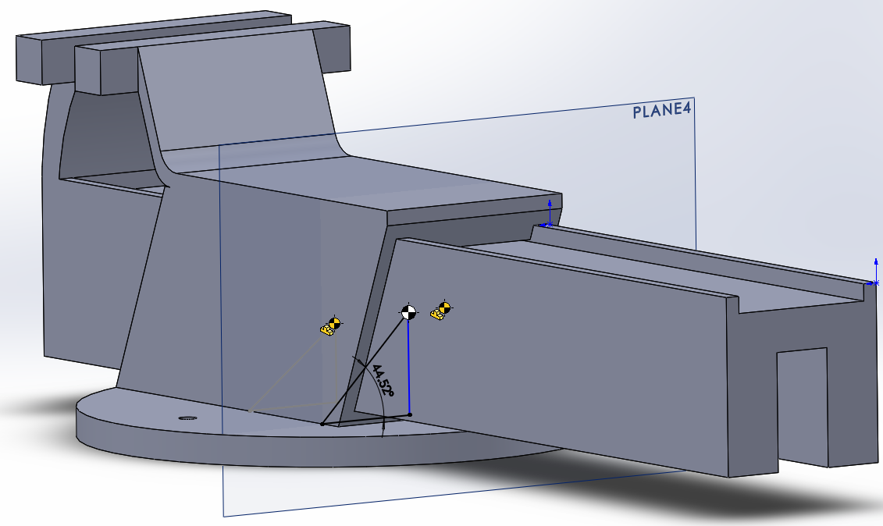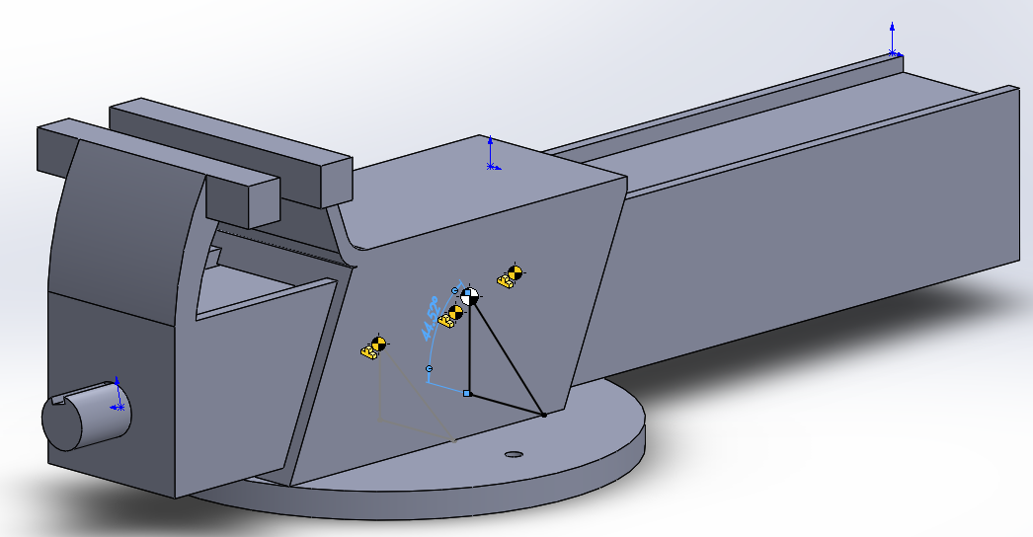

* Adding the screw (Part3) had little to no effect on the overall COM and stability.
* Adding the slide (Part2) increased the stability angle from 37.21° to °44.52, this will in theory reduce the stability.

## Graspability Analysis

A Graspability analysis was conducted on the main parts of the vice using a Graspability matrix. The parts were rated in a scale between 0 to 5, with 0 being the lowest ability for a robot to grip the part and 5 is the highest.

The static jaw has a few shapes to it; the cylindrical base, rectangular slot and a slope leading to a rectangular jaw, but if it was held horizontally, it has a space where the robot could hold it. Hence, $G_{1}=3$.

The sliding jaw has a horizontal space where the robot can easily grip. Hence, $G_{2}=5$.

The 360 mm screw has a cylindrical shape and the estimated Graspability is $G_{3}=3.$

$G$ = $\left[\begin{aligned}G_{1}=3 \\ G_{2}=5 \\ G_{3}=3\end{aligned}\right]$ = $\left[\begin{matrix}G_{11} & G_{12} & G_{13} \\ G_{21} & G_{22} & G_{23} \\ G_{31} & G_{32} & G_{33}\end{matrix}\right]$

## Workcell Layout in FIAB

The workspace layout was set to maximise the efficiency of the robots and was determined by the configuration of robot and the type of end-effector used. Figure 5 shows a **to-scale** **portion** of our linear production line layout. Considering conveyer and robot footprint specifications, the decision to utilise flexible and intelligent robots has allowed space for humans enter the ‘FIAB’ container to maintain the machinery. Container size: 12.2m length, 2.43m width, 2.59m height.



Yamaha MXYx storage and organization gantry (Cartesian)

Figure 5. FIAB layout for Vice assembly

## Development of optimized sequence plan for automated assembly

The following figure shows an in-depth sequence plan for processes 1 & 2 shown in figure 5.

From Figure 5, the travel sequence of the robots is identified and depends on the material flow to produce a complete vise. The sequence plan timings are displayed in figure 6 below. A full cycle takes 26 seconds, and one 3 part vice is produce every 8 seconds (7 Vice/minute).

**Travel Sequence: Static Jaw – FF1 – Sliding Jaw – FF1 – FF2 – Screw Storage – FF2**

FF1 and FF2 are flexible fixture 1 and flexible fixture 2, respectively.

Cycle time disclaimer: The cycle time is required to find the optimum workspace layout and suitable robot configuration. However, the methods to find the travel time between two worksites are inaccurate as the methods consider the end-effectors to operate with constant velocity whereas in real life applications, constant joint velocity is not implied.

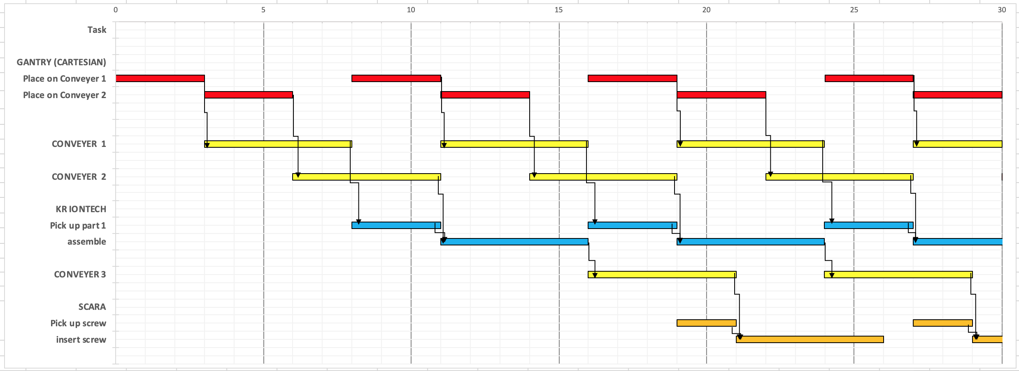

Figure 6. Manufacturing sequence plan of 3 parts (processes 1-2)

## Consideration of required robot operations

Each component can be grouped into families according to robotic handling and the select grippers/end effectors to handle them. There are several factors to consider such as: size and weight, shape and material. The components can be split into two families:

##### Flat surfaces: base, static jaw, slide, sliding jaw and dynamic jaw

##### Solids of rotation: nuts, bolts and screws

Flat surfaces and solid of rotation can be assembled by gripping and screwing processes respectively.

### Gripping processes

* Type of motion: Angular
* Number of fingers end-effector: 2 or 3
* Actuation: Pneumatic or electric
* Per station: x1 (or more)

Size and weight are fundamental in **gripper** selection, as the **end-effector** precision is highly dependent on the weight capability. As a matter of fact, if the component were to exceed the weight limit of the gripper, this could result in slippage, causing a loss in orientation during the loading, unloading and/or moving process(-es)4.

**Shape** is a very important factor, as it can determine the capability of a specific gripper to perform a task on said component. **Material** is another aspect to be taken under consideration, although the main concern regarding the material of the component (i.e. the weight that this would imply) has already been contemplated above. Therefore, this aspect regards more the possibility of friction, wear, and any other THING between the two different surfaces (gripper and part) that could damage the element.

For the assembly of the flat vice components a **spherical** **articulated** and/or **cartesian** robot could be utilised. The former can conduct the main complex assembly processes due to its ability to manipulate the orientation of the workpiece. The latter can transport components of varied shape and size with high speed and accuracy. Finally, **Cartesian** robot will be used for the automatic storage and replenishment system inside the FIAB. Operating from the far end of the container (at the beginning of the production process).

### Screwing processes

* Type of motion: rotational
* Actuation: Pneumatic or electric
* End-Effector: magnetic
* Per station: x1 (or more)

Cylindrical robots are an inexpensive option for moving assembly pieces from one workstation to the next, while utilising a small footprint - perfect for FIAB setting. **SCARA** robots are an extension of cylindrical articulated robots and provide fast, accurate and reliable function5. In industry SCARA robots are commonly used for small assembly applications, they also articulate in the **rotation** axis supporting screw driving applications6.

**Magnetic** end effectors can be employed to lift small nuts and bolts under 50g. This allows rapid and flexible deployment for over 10 million cycles7.

## Flow matrix analysis

The flow matrix shows the number of trips the robots have to complete between two machines during a period. (Resource 3.1 – 4)

Each entry in the flow matrix represents the number of trips the robots have to perform to produce a vise. A zero entry shows that the robot will not have to travel during this period.

$$Flow Matrix=\begin{matrix}Static Jaw \\ Sliding Jaw \\ FF1 \\ Screw Storage \\ FF2\end{matrix}\left[\begin{matrix}0 & 0 & 1 & 0 & 0 \\ 0 & 0 & 1 & 0 & 0 \\ 0 & 1 & 0 & 0 & 1 \\ 0 & 0 & 0 & 0 & 1 \\ 0 & 0 & 0 & 1 & 0\end{matrix}\right]$$

## Robot parameters in FIAB environment (reach, work volume, payload)

Appendix item 1 shows the FIAB floor plan, which states the container as size 12m by 2.4m by 2.6m (LxBxH). With this limited space in mind it is essential to consider robot parameters and optimise capacity utilisation. The required parameters are:

**Minimum and maximum reach:**

* Gantry: within 2400mm container width
* Spherical Articulated: 800mm to 2400mm
* (Cylindrical Articulated) SCARA: 600mm to 1000mm

**Work volume:**

* Gantry: 900mm x 2100mm floor area
* Spherical Articulated: 6 DOF, 400mm x 800mm x 800mm
* SCARA: **4DOF**, 400mm x 400mm x 800mm

**Payload:**

* Gantry: Up to 15kg
* Spherical Articulated: 10 – 50kg Medium payload
* SCARA: 1kg minimum

# Automation Support Systems

## Justification for robot selection

### Size & key selection parameters

#### Storage and organisation gantry robot (Cartesian)

Gantry robots are a type of cartesian design and are typically used by mounting over the work area for pick and place operations. Cartesian robots are rectilinear systems that move along the X, Y, Z axis and can be powered by either an electrical or hydraulic drive. Gantry Benefits include:

* 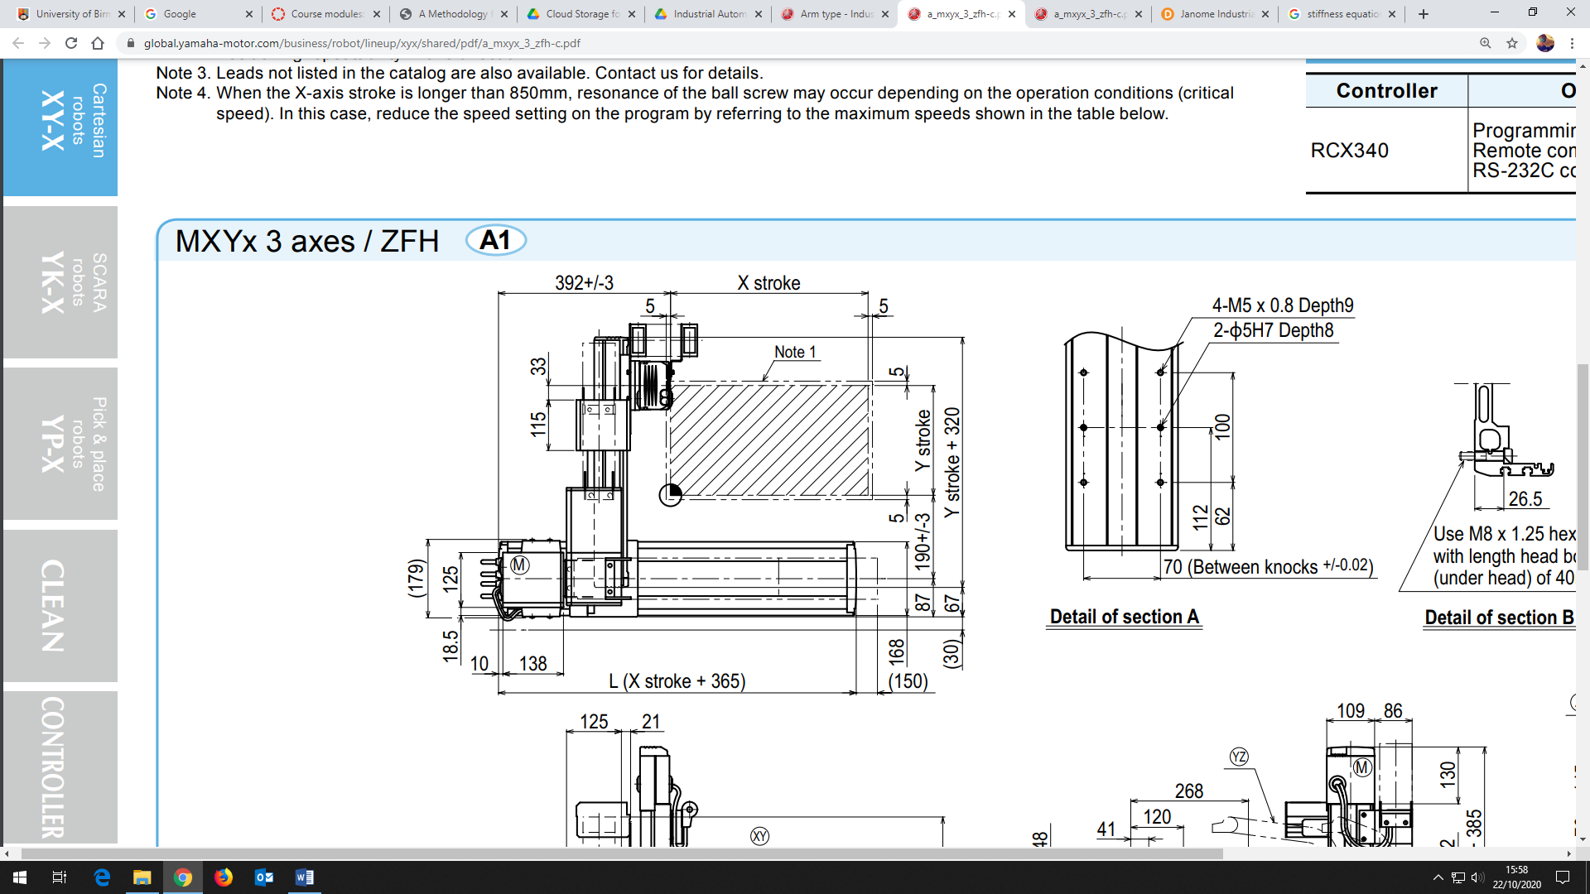Increased speed of material handling
* Can handle heavy-weight items and transfer them at lifting height
* Can handle variation in products
* Increased safety and autonomy by eradicating operator handling
* Allows for 24hr operation with minimum staff involvement

The Yamaha MXYx product: this cartesian arm has 3 axis and operates at 200W. The ZFH type has a higher rigidity compared to other standard 3-axis cartesian robots. More compact than other cartesian products, the Yamaha MXYx can have a maximum payload of 14kg.

Figure . Yamaha MXYx dimensions

|  |  |
| --- | --- |
| Repeatability (mm): +/-0.01 | Type: Cartesian |
| Drive System: Ball Screw | Payload at max reach: 6kg |
| Max. Speed (mm/s): 1200 | Operation Method: Remote Command |
| Moving Range (mm): 1250(X), 650 (Y), 350 (Z) | Number of Axes: 3 |

*Table displaying size and force parameters*

#### SCARA robot (FANUC SR-6iA)

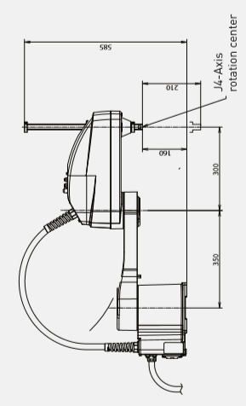The FANUC SR-6iA is an inexpensive and reliable option for the screwing processes, offering speed and precision within a lightweight compact frame.

4DOF, Max reach: mm, Max payload: 61kg

Key **FIAB** selection details ot the FANUC SR-6iA include:

* Selective compliance
* High stiffness in y, although high stiffness not always desirable
* low in the horizontal plane

Figure 8. FANUC SR-6iA dimensions

#### Spherical Articulated robot (KUKA IONTECH)

The KUKA IONTECH has been chosen to operate assembly processes (e.g. sliding jaw -> base). The articulated robot **meets the design specification requirements** for this procedure, including work volume8.

6DOF, Max reach: 2101mm, Max payload: 61kg

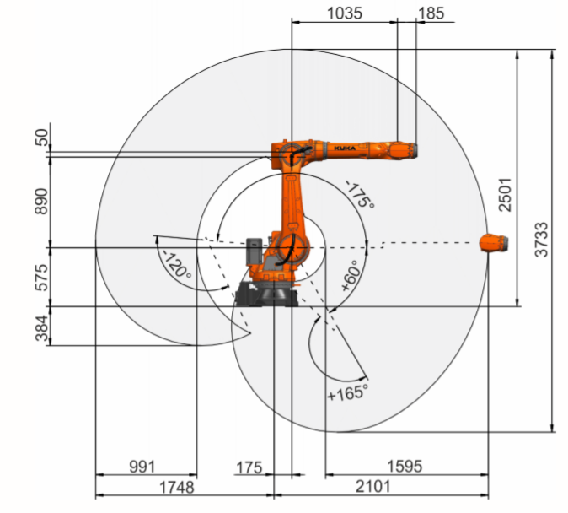

Key **FIAB** selection details ot the KUKA IONTECH include:

* Dustproof and waterproof
* Use in temps 0’ to 55’C
* Low space requirement: Small footprint & streamlined disruptive contour allow compact cell design (FIAB)
* Mean time between failures 400,000 hours

### Stiffness analysis

Figure 9. KUKA IONTECH work range

#### Storage and organisation gantry robot (Cartesian)

For our FIAB, the Yamaha gantry robot will be used to supply parts to line conveyers. The max payload of 14kg has been selected for analysis.

|  |  |  |
| --- | --- | --- |
|  | $$E= \left({\frac{L}{4bh}}^{3}\right)\left(P.d\right),$$ | **(4)** |
|  | Where,  12kg  1615mm (Xstroke+365)  Figure . Diagram of Yamaha MXYx modelled as simply supported beam $\frac{p}{d}=$ Stiffness $E$ for steel = 200 GPa $b$ (width) = 132mm $L$ (length) = 1615mm $h$ (height) = 400mm $P$ (Payload) = 14Kg |  |
|  | = mm4 | **(5)** |
|  | mm | **(6)** |
|  | Inertia = mm4  Deflection = $7.15×10^{-4}$ mm  Stiffness = 1.96 $×10^{4}$ kg/mm |  |

#### SCARA robot (FANUC SR-6iA)

Calculations for SCARA deflection and stiffness when modelling as a cantilever beam, with a max payload of 6Kg:

|  |
| --- |
|  |
|  | = mm4 |  |
|  | mm  400mm  100mmm  350mm  6Kg  350mm  Figure . SCARA robot modelled as cantilever beam | **(7)** |
|  | Where, $I$ beam Inertia $E$ for steel = 200 GPa $L$ (length) = 700mm $b$ (width) = 130mm $h$ (height) = 400mm $P$ (Payload) = 6Kg  Deflection = $4.94×10^{-12}$ mm  From Equation (4): Stiffness = $1.21×10^{12}$ kg/mm |  |

#### Spherical Articulated robot (KUKA)

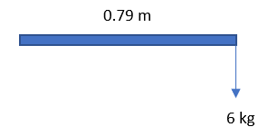

Figure . KUKA IONTECH modelled as a cantilever beam

Using equations (4,5 & 7) and young’s modulus of steel as 200GPa the Inertia, Stiffness and deflection of the KUKA arm can be calculated. Assuming the system acts as a cantilever beam:

Inertia, I = 0.00005644 m4

Stiffness, k = 0.0687 kg/m

Deflection, d = 0.4122 m

## End-effector design, justification and compliance analysis

**Selection of compliant gripper for assembly task & compliance analysis**

For the KUKA IONTEC assembly process an adaptive electric two finger gripper has been selected to grasp the sliding jaw part externally via the middle COM grasping point, the part will then be locked in two axis and can be manipulated accordingly. With a form-fit payload capacity of 5kg, the gripper will be able to hold part securely.

In the future this commercially available hardware offers much flexibility, as with much of the machinery incorporated into our FIAB. This adaptive nature is the future of the manufacturing industry as a customizable service, a concept which FIAB can amplify.

Robotiq’s 2f-85mm gripper11 has automatic part detection and position feedback, if a mis-alignment were to occur the axial force will be felt by the robot hand and the interaction can be assessed. Through machine learning lies the potential for small adjustments to be made.

Suitability of Passive Compliant Device to Aid Robotic Assembly (Peg in Hole):

From the McCallion et al paper12, the use of passive compliant device is suitable to aid robotic assembly given that the pegs have small diameters and length, and the pegs must be centrally placed on the device for the insertion to occur. The screw in our case is of length 360mm, the screwdriving SCARA robot and selected magnetic gripper must operate with ±1mm precision.

Chamfer of angle θ is applied to part 2 outlet for compliance assisted assembly12.

|  |  |
| --- | --- |
|  | **(8)** |

## Sensors & Systems

### Sensors

Sensors play an essential part in autonomous manufacturing. This feedback allows communication within a system and thus autonomous function itself. It is pivotal the correct sensors are used in each process to ensure function, safety, quality control and data analysis.

***Table 1.*** *Sensor specifications*.

|  |  |
| --- | --- |
| Design Aspect | Design Objective |
| Purpose | Factory in a Box application. |
| Performance | High accuracy. |
| Dimension | Suitable with the chosen end-effector and the robot arm. |
| Environment | Capable in working in harsh environment; dry, cold, warm, or dusty. |
| Connectivity | Able to connect via to wi-fi for remote working.  Applicable to the internet of things sensing. |

**ATI-IA Multi-Axis Force/Torque Sensor**13

* The IP60 models are suitable for dusty conditions.
* Silicon strain gages provides noise immunity and has high overload protection.
* High accuracy & resolution sensor over wide temperature range.
* Biasing to offset tool weight.
* Threshold detection to integrate into industry usage.
* Can be customised.
* Requires experienced engineers to aid.

**Visevi Robotics vision sensor**14

* Six axis camera-based sensor system.
* Positions determined using visual markers.
* Force sensing uses deformable element.
* Camera sends the image to the software for measurement calculations.
* Auto calibrated.
* Relies on passive sensitive element, without electronics.
* Cost efficient.
* Easily adaptable.

From the 6 best Industry 4.0-ready sensors that we found. Both **ATI-IA Multi-Axis Force/Torque Sensor** and **Visevi Robotics Sensor** will be applied in our FIAB due to their state-of-the-art technology.

### Quality assurance systems (Visual)

Inspection systems within a smart factory can not only be used to have a visual check on incoming/outgoing components, but also to see how the robots are performing within the work cell. Industry 4.0 inspection systems will be able to predict structural failure and plan future maintenance on various robotic work cells before they fail. This will reduce down time of operation for maintaining broken robots.

**PROline Ultrasonic Inspection System:**  
Ultrasonic testing device that is Industry 4.0 ready. PROline systems can be used as a stand-alone device or integrated directly into a production line, allowing for fully automated testing. The testing device looks at the quality of primary materials and end products, looking for cracks, material volume defects, coating connections and wall thickness:

* Flexible integration into the FIAB configuration
* Robust Design
* Software compatible with external and internal systems
* Integrated Sequence Control
* Automated Evaluation of parts
* Real-time results display

### Industrie 4.0 & systems integration (Smart Factory in a Box)

Industry 4.0 is the future of flexible, autonomous and unrestrained manufacturing. In which all aspects of factory production, both internal and external to the business, are integrated. Primary data from robots and sensors is sent to the “edge” through network gateways. This “big data” can then be evaluated and processed into “smart data” for use in making real-time business decisions.

Intelligent communication across the business allows for efficient leasing with suppliers and customers. Furthermore, a portfolio of mobile applications is being developed for robot accessibility and client customisation purposes.

All this data can be stored on the cloud for legal and robot learning purposes. With developments in deep learning robots can now communicate in social groups, sharing information based on experience to each other across the cloud. With regards to what is commercially viable within the FIAB setting the following systems and devices will be utilised:

1. Digital value chain

The digital chain consolidates **all data from supplier to manufacturer to customer**. With the accurate implementation of intelligent machines this process will drive **sustainability** and **efficiency**. Purchasing and replenishment will become fully autonomous. For FIAB this means less storage, making the system more mobile.

1. Manufacturing as a Service

The modern manufacturing line will **not be owned** but let out as a service. FIAB is a mobile factory and such has **great commercial potential** as a service. In fact, any intelligent, flexible, collaborative workstation inside a mobile container has great service commercial viability.

1. Predictive maintenance & Monitoring/ Stream Analytics

It is currently common place to see preventative maintenance preferred to reactive due to downtime loss reductions. Yet, predictive maintenance identifies cautionary **patterns or trends** in live data being fed through the ‘edge’ via network gateways. Monitoring position, force and torque sensors of six-axis robots in the FIAB will result in dependable production planning and increased machine availability.

1. Digital Twin

A digital twin is a digital replica of any physical asset. In the FIAB setting, real time data from sensors can also be applied to the 3D digital twin to mimic the life cycle of the asset. This can be used to understand failure points or optimise the process.

### Flexible fixtures

General fixtures in manufacturing are used to secure, position and support various workpieces so that processing operations such as machining or assembly can be performed on the part. However traditional fixtures tend to be bespoke and cannot be adapted for multi-use purposes. Flexible fixtures are concepts that are designed to increase the adaptability of what the fixture can secure, allowing manufacturing work cells to be able to adapt depending on the geometries of the workpieces.

|  |  |  |
| --- | --- | --- |
| **Flexible Fixture Concept** | **Application** | **Characteristics** |
| Modular Fixtures / Pallet Systems | General assembly and machining of workpieces | Fast reconfiguration times for workpieces of varying geometry. Lower accuracy than other flexible fixtures.  Low cost compared to other flexible fixtures, but higher than a conventional fixture. |
| Automatically Reconfigurable Fixtures | General assembly - typically used for larger components | High cost so applied to highly automated large volume manufacturing.  Loading and set-up can be fully automated. |
| Sensor-Based Fixture Design | Fixture components | Sensors to equip loading a workpiece with a greater level of accuracy.  Sensors are expensive and require to be connected with other equipment. |
| Phase-Chance Based Fixture Design | Machining | Very flexible form of fixturing.  Phase-change materials are toxic and require careful handling to prevent damage to health. Expensive operational costs. |

# References (Section 1):

1. PhysicsTeacher.in. 2020. The Friction Coefficient, Definition, Equation, Table, Coefficient Of Friction. [online] Available at: <https://physicsteacher.in/2019/10/13/friction-coefficient/> [Accessed 17 November 2020].
2. Engineering Product Design. 2020. Keys & Keyways Specification | Engineering Product Design. [online] Available at: <https://engineeringproductdesign.com/knowledge-base/keys-keyways-specification/> [Accessed 18 November 2020].
3. A compliant device for inserting a peg in a hole H. McCallion, G.R. Johnson and D.T. Pham, University of Canterbury, New Zealand
4. Families of components grippiing paper
5. Machine Design. 2020. The Difference Between Cartesian, Six-Axis, And SCARA Robots. [online] Available at: <https://www.machinedesign.com/mechanical-motion-systems/article/21831692/the-difference-between-cartesian-sixaxis-and-scara-robots> [Accessed 18 November 2020].
6. Fanuc.eu. 2020. SCARA Robots. [online] Available at: < https://www.fanuc.eu/uk/en/robots/robot-filter-page/scara-series/scara-sr-6ia > [Accessed 18 November 2020].
7. Design with us. 2020. Magnetic Gripper End Effector — Design With Us. [online] Available at: <https://www.designhawkllc.com/mg1> [Accessed 18 November 2020].
8. Yamaha Motor Co., Ltd. 2020. Arm Type. [online] Available at: <https://global.yamaha-motor.com/business/robot/lineup/xyx/arm/> [Accessed 11 December 2020].
9. KUKA AG. 2020. KR IONTEC | KUKA AG. [online] Available at: <https://www.kuka.com/en-gb/products/robotics-systems/industrial-robots/kr-iontec> [Accessed 19 November 2020].
10. Blog.robotiq.com. 2020. [online] Available at: <https://blog.robotiq.com/hubfs/Product-sheets/Adaptive%20Grippers/Product-sheet-Adaptive-Grippers-EN.pdf> [Accessed 19 November 2020].
11. Baohua Zhang, Yuanxin Xie, Jun Zhou, Kai Wang, Zhen Zhang, State-of-the-art robotic grippers, grasping and control strategies, as well as their applications in agricultural robots: A review, Computers and Electronics in Agriculture, Volume 177,
12. (McCallion, Johnson et al. 1979)
13. Ati-ia.com. 2020. ATI Industrial Automation: Multi-Axis Force / Torque Sensors. [online] Available at: <https://www.ati-ia.com/products/ft/sensors.aspx> [Accessed 14 December 2020].
14. Visevi.com. 2020. Visevi Robotics. [online] Available at: <https://www.visevi.com/en/technology.html> [Accessed 14 December 2020].

# Appendix (section1):



Figure 13. To-scale Layout of FIAB robotic workcell

Section 2

# Abstract

# Introduction

# Aim & Objectives

#### Aim

#### Objectives

# Literature Review for the Research-focused Automation

## 4.01 Literature review & Critical evaluation

# Methodology

## 5.01 Flexible Fixtures and Industry 4.0

## 5.02 Design of novel flexible fixture for vice assembly

#### CAD views of novel flexible fixture design

#### Structural and force requirements

#### Exploded view (Appendix)

#### Bill of materials (Appendix)

## 5.03 Critical analysis of flexible fixture

#### Stiffness analysis

#### Positional accuracy & repeatability

#### Locking mechanism

#### Cycle time & Reconfiguration timings

#### Stability & Graspability

#### FEA method

# Results, Discussions and Conclusions

## 6.01 Results

#### FEA

## 6.02 Discussion

#### Design altercations

#### Wider applications of Novel design

#### Future research and opportunities

## 6.03 Conclusion

# Abstract

Flexibility is the ability to react quickly to changing influence. In this paper a novel concept flexible fixture is applied to the FIAB work cell to improve the flexibility of a manufacturing system. It has been designed to locate and fix for assembly purposes, specifically the ‘peg in a hole’ insertion method. The design is modelled for torque and force calculations to ensure the motor and actuator is able to lift and rotate the workpiece. A locking mechanism which consists of four suction cups is incorporated in the design to ensure the workpiece is secured in position while assembly takes place. Extensive research is conducted into existing fixation methods and suction cup capability.

From the finite element analysis completed on the actuator lifting the workpiece, a maximum displacement of 1.263 $×{10}^{4}$ m is observed. This is then compared with the stiffness analysis, which calculated a displacement of 1.201 $×{10}^{4}$ m, resulting in an error of 4.9%. Wider implications and future research opportunities are investigated and there is great potential for the flexible fixtures to be integrated with smart sensors to allow for complete industry 4.0 integration.

# Introduction

For there to be innovation in commercial products, there must be innovation in the manufacturing process that is behind these changes. As is with modern day consumerism, constant developments and upgrades to products requires a flexible manufacturing system to ensure machining and assembly processes remain efficient and cost effective. One such development in manufacturing is the concept of Factory in a Box (FIAB). This paper aims to look at flexible fixtures and how they can be applied to within a FIAB concept, investigating novel steps taken to produce efficient and adaptable work stations. From this research, our own flexible fixture will be designed using new research to help maximise efficiency within the FIAB setting.

# Aims & Objectives

#### Aim

* Device a novel flexible fixture to increase the flexibility of a robotic workcell

#### Objectives

* To study existing literature considering the design implementation of flexible fixtures in industry
* Integrate a concept into FIAB and conduct critical analysis
* Consider implications, wider use and future research opportunities of our design

# Literature Review

## 4.01 Literature review & Critical evaluation (flexible fixtures and fixation methods)

The manufacturing industry is a sector of engineering where constant technological advancements and market trends requires it to advance in conjunction with these developments (Singholi et al., 2013). One such sector of manufacturing that demands constant progression is the need for flexible manufacturing, to meet ever-changing design trends and production rates to ensure an efficient and economic system. For a manufacturing process to allow for variations of products to be produced on an individual production line, fixtures must be able to accommodate a wide range of different components to create a flexible manufacturing system. In many industries, custom-oriented dedicated fixtures do not have the flexibility to deal with parts or assemblies of different shapes and sizes and they are also time-consuming and costly to build (Bi and Zhang, 2001). Flexible fixtures are seen as a way to combat these manufacturing inefficiencies, allowing for workpieces of different geometries to be fixed and secured onto one single fixture. This literature review aims to look at innovations within flexible fixtures, analysing and contrasting various methods to see how fixtures can be adapted to dealing with varying geometries or workpieces. In particular, there will be a careful focus on how such flexible fixtures can be applied and adapted to fit within a FIAB setting.

Enhancing product quality whilst reducing lead time is the challenge manufacturing systems find themselves in within current climates. Mass customisation for customer demand is an ever-increasing market, where traditional fixture technologies do not possess the flexibility required for rapid altercations to the manufacturing process (A. llidge and G. Bright, 2018). K. Dröder et al. (2016) backs this claim, stating that modern manufacturing trends call for a more flexible and versatile production system to meet trends where changing products have many different geometries. Fixtures can amount to 10 - 20% of the total manufacturing cost of a production line. The paper indicates that a major way of reducing manufacturing costs is to utilise flexible fixture systems, in which it should be designed to be competent in fixturing as many workpieces as possible (G. Suman and R. Tilak, 2017). Whilst G. Suman and R. Tilak (2017) focus on the cost efficiencies associated with flexible fixtures, E. Ilker et al. (2020) highlights that the key issue is not cost but reducing the individualisation of filtering tooling. Fixturing tools are often too individualised and processes for mass flexability requires a much more universal approach than the conventional fixtures. Whereas generic fixtures in manufacturing and assembly are used to secure, position and support various workpieces so that various operations can be performed on the part, flexible fixtures are concepts that are designed to reduce time of manufacture by allowing an increased scope of what it can support (O. Bakker et al, 2013). Flexible fixturing designs can be classified into seven categories.

Flexible fixtures must be able to accommodates a large variety of product families and geometries, have automated setups and setup changeovers whilst having adaptive feedback during machining or assembly processes (A. llidge and G. Bright, 2018). Flexible fixtures must adhere to the same functional standards as regular fixtures, high rigidity, accurate repeatability and a positive location. A fixture must hold the workpiece precisely in space to prevent each of the spatial movements, i.e., linear movement in either direction along X, Y and Z axes and rotational movement in either direction about each axis (Suman and R. Tilak, 2017). Designed wrong however and flexible fixtures fail to function as required, causing serious limitations to their use. A flexible fixture designed inefficiently to secure products of varying geometries result in over-clamping and excessive vibrations. For flexible fixtures used in machining, dimensional inaccuracies, reduced surface quality and separation between the workpiece and fixture can all occur from insufficient flexible fixtures. This can halt production, wiping all efficiency gains that come from the concept of flexible fixtures (Bakker et al., 2012). Whilst Bakker et al. (2012) looks at the machining aspect of flexible fixtures, a later study by Bakker et al. (2013) focuses on potential issues with flexible fixture in assembly sequences. Fixture performance is determined by the surface quality and dimensional error of the workpiece once the machining and assembly processes have been carried out. Poor fixture performance can lead to workpiece and fixture deformation due to clamping forces; locating errors due to tolerances; locator placement and dimensions and poor workpiece positioning. Although supports can be implemented below workpieces to prevent or constrain deformation of the part, Tolerance sensitivity analysis, accessibility analysis and stability analysis can be done on the fixtures to validate their design (Bakker et al., 2013).

Flexible fixtures can be split up into three distinct categories, these are modular fixtures, conformable fixtures and reconfigurable fixtures. Modular fixtures use varied components that can be arranged to suit a large variety of component (A. llidge and G. Bright, 2018). Modular fixture consists of many elements, such as a baseplate, locators and clamps. These fixtures are flexible, right up until the point of assembly. They are used mainly for single-part production and small-batch manufacturing V. Ivanov et al. (2018). H. Du et al. (1998) shows the limitations of modular fixtures as they are limited by number of parts and require downtime for different set ups that are performed using either a robot or manually. Although published in 1998 and over a decade of development has gone into modular fixtures since, this still is a large problem with modular fixtures. This is further agreed upon as A. llidge and G. Bright. (2018) findings show disadvantage including long set up times of fixture design where new parts require fixing in place. Despite modular set ups having long configuration redesign times, Wei et al. (2018) simulations show that for pipeline assembly within aircraft, modular flexible fixtures can have great benefits to the efficiency of the system. Modular design assembly modes require a lot less time for assembly than the traditional manual way, which makes the assembly efficiency increased by 60 to 75% in terms of assembly of a tube joint. Roughly, the assembly time of the entire pipeline is increased by about 45 to 50% compared with the conventional mode (Wei et al., 2018).

Conformable flexible fixtures are a new and novel approach to securing workpieces for machining or assembly operations. The fixture conforms to the geometry of the part they are fixing in place, changing its own geometry to fit the part. Examples include pin matrix and phase changing conformable fixtures (A. llidge and G. Bright, 2018). Examples of conformable fixtures include phase-change based fixture design where a substance conforms and secures around the workpiece. Very flexible form of fixturing. However, Phase-change materials are however toxic and require careful handling to prevent damage to health (O. Bakker et al., 2013). Further, they are expensive in terms of operational costs and are not effective locators (A. llidge and G. Bright., 2018). Research in conformable fixtures formed the basis of K. Dröder et al. (2016) study around flexible end effectors for workpieces with many variants in geometries. Similar to conformable fixtures, this vacuum styled phase changing end effector allows for fast set-up with low operation and maintenance costs for versatile production systems.

In flexible fixtures, the grasping device plays an important role in the handling of the workpiece, and there are several processes noted by Fantoni et al. (2014) which are being underestimated as humans find it familiar. These processes include approaching the workpiece, getting in contact, increasing force, ensure the workpiece is secured, moving, and releasing the workpiece. The design of gripper varies according to the application, such as, vacuum grippers, friction grippers and jaw grippers. Despite the developments made in the grasping part, the consumer goods industry is still having lack of fast solution to improve the production rate. This is also mentioned by Tichem et al. (2004), where the demands of production are varied according to applications, and higher productivity is required in industrial, high volume assembly process. The choice of gripping system is influenced by the workpiece characteristics such as the mass, rigidity and dimensions. Vacuum gripper is used widely in the packaging and robotics industry as it has a gentle grasp even on big and heavy objects. However, there has been limited studies regarding the suction cup models focusing on determining the load limitations when the workpiece is moving (Schmalz et al., 2016).

# Methodology

## 5.01 Flexible Fixtures and Industry 4.0

The influence of industry 4.0 on an asset level, is networking. The ability for different manufacturing stages to be merged via the cloud allows for seamless autonomous production. To achieve this all assets must be integrated vertically including intelligent flexible fixtures, to behave as one system (Moshiri et al., 2020). Industry 4.0 will further increase flexibility of the following concept design via:

* Autonomous self-configuration
* Machine learning
* Predictive maintenance
* Energy efficiency
* Social understanding
* Collaboration with robots

Communication between all assets in one system allows for rapid re-configuration, the following flexible fixture design must be capable of self-reconfiguration. Smart sensors will supply live output data for real-time monitoring and consequently, predictive maintenance from the ’edge’ gateway. Other benefits include self-awareness, which allows greater energy efficiency and feasibility of collaborating with humans and robots. Finally, a social understating will let assets communicate about part properties and dimensions, further increasing flexibility. This all requires unified integration between the flexible fixture and the IoT (internet of things) (Aheleroff et al. 2020).

## 5.02 Design of novel flexible fixture for vice assembly

#### CAD views of novel flexible fixture design

Figure . 1-4 CAD views of Flexible fixture (1. In situ, 2. lowered position, 3. raise & adjusted, 4. Holding product in fixed position)

#### Structural and force requirements

The fixture can be modelled for force and torque calculations much like the vice itself. The actuator and motor are required to have sufficient **force** and **torque** to hold and rotate an 8kg part. The coefficient of friction for rubber on steel (dry) is estimated at 0.64 with frictional forces being applied by both jaws(Engineering Edge, 2020).

|  |  |  |
| --- | --- | --- |
| Where, $F$ = Downward force $M$ = mass $a$ = acceleration $f_{f}$ = Frictional force $R$ = Clamping force (Normal force) $μ$ = coefficient of friction $τ$ = Torque $r$ = radius of actuator $∅$ = angle between F and the lever arm |  |  |
| $F=ma$ $= 8×9.81=78.5N$ | **(1)** |
|  |
| $$2f_{f}=78.5 N ∴ f_{f}=39.2 N$$ |  |
| $f_{f}=μR$, $(R)= \frac{39.24}{0.64}=61.3 N$ | **(2)** |
|  |
| $$τ=R× r × sin∅$$ $$τ= 408.33 × \frac{12}{2} × 10^{-3}×sin \left(90\right) =0.37 N m$$ | **(3)** |
|  |

The required force from each actuator to hold the 8kg vice is **61.3N.** As the lifting suction cups are directly coupled with the Servo motor, the **max required torque** to rotate the Vice is **0.37N m**.

***FOR EXPOLED VIEW iii) and BILL OF MATERIALS iv) SEE APPENDIX***

## 5.03 Critical analysis of flexible fixture

#### Stiffness analysis

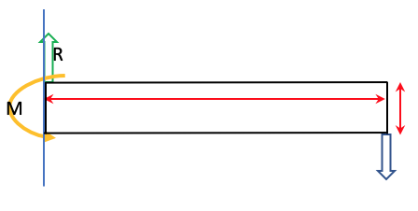Despite the model being of a complex geometry, a simple stiffness analysis could be carried out. This is because the robotic arms can be approximated to a cantilever beam, with a rectangular cross-section.

Material used: Cast alloy

Young’s modulus: $E=3 GPa$

The length of the beam: $L= 0.063 m$

Height of beam: $h=0.012 m$

Figure 6. Bending moment diagram of Flexible Fixture centre actuator

Force applied to the end of the beam:

|  |  |
| --- | --- |
| $$F=4 kg*9.81 \frac{m}{s^{2}}=39.24 N$$ | **(4)** |

In order to find the beam stiffness, the first moment of area ($I$) is calculated:

|  |  |
| --- | --- |
| $$I=\frac{L*3}{12}=\frac{0.063*{0.012}^{2}}{2}=9.072*{10}^{-9} m^{3}$$ | **(5)** |

The beam stiffness ($k$) can be hence calculated as:

|  |  |
| --- | --- |
| $$k=\frac{48*E*I}{L^{3}}=\frac{48*800*{10}^{6}*4.536*{10}^{-6}}{{0.063}^{3}}=1.39*{10}^{6}\frac{kg}{m}$$ | **(6)** |

The displacement ($y$) can be calculated as:

|  |  |
| --- | --- |
| $$y=\frac{F*L^{3}}{3*E*I}=\frac{39.24*{0.063}^{3}}{3*3*{10}^{9}*9.072*{10}^{-9}}=1.201*{10}^{-4} m$$ | **(7)** |

The reaction force is equal but of opposite direction to the applied load, therefore:

$$R=-39.24 N$$

The bending moment at the support is:

|  |  |
| --- | --- |
| $$M=x*F$$ | **(8)** |

Where $x=L$

Therefore,

$$M=0.063*39.24=2.4721 N*m$$

Given the calculated results, it is possible to sketch the shear force diagram as well as the bending moment diagram, as shown below:

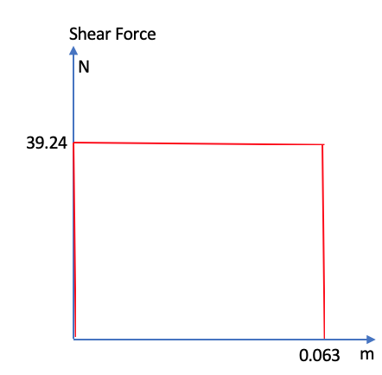

Figure 7. Shear Force diagram

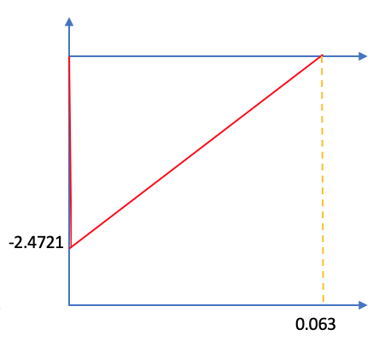

Figure 8. Bending moment diagram

#### Positional accuracy & repeatability

Accuracy needs to be considered from two perspectives. First the accuracy of the actuator itself, and then accuracy of the system. The commercial actuator used has a 0.1 μm resolution encoder (RS Components, 2020). Studies show similar actuators can operate within an accuracy of 1 μm even with uncertainty considered (Dalla Costa et al., 2017). The conveyer is in an extension of the vision system responsible for locating the product. The vision sensors operate with a high degree of accuracy, and high response speed to position the conveyer, and consequently product.

#### Locking mechanism

In the design, the vertical suction gripper at the lower section of the flexible fixture ensures the vise is stable and remains static when the part is being assembled.

Standard suction cups are used in our design as it is suitable for lifting and gripping flat part, stable when gripping a part and can grip a part in a short period due to the internal volume (Letourneau, 2019).

To validate the locking mechanism of the flexible fixture, the calculation below is being done on the centre and two side suction grippers based on the vertical configuration:

|  |  |
| --- | --- |
| $$F=\left(\frac{m}{µ}\right)×\left(g+a\right)×S$$ | **(9)** |

Where,

$F$ = Theoretical holding force of suction gripper (N)

$m$ = Mass (kg)

$µ$ = Surface friction coefficient

$g$ = Gravitational acceleration (9.81 m/s2)

= Acceleration of system (m/s2)

= Safety factor

The mass of the workpiece was taken to be 1.34 kg as it is being distributed between six suction cups. The friction coefficient was taken to be 0.5 for metal surface (Jaiswal and Kumar, 2017), and the acceleration is 30 m/s2 for pneumatic system (Festo, 2006). The safety factor was taken as 1.5 for the two side suction cups moving vertically and horizontally and a safety factor of 2.0 was applied to the middle suction cup moving vertically and rotating. (Festo, 2006).

By substituting the values into the equation, the theoretical holding forces of each suction gripper were obtained.

$F=213.4 N$ (centre suction cup)

$F=160.0 N$ (side suction cup)

Based on the calculated forces and the selected shape of the suction cup, the suitable cup diameter for the vise is 80 mm (Festo, 2006), and fluoro-rubber is chosen as the material as it has a wide range of operating temperature; between -10 °C to +200 °C (Festo, 2006), and has outstanding chemical resistance (Letourneau, 2019), which is suitable for the project.

An assumption made to the design was the compliance of the robot arm is greater than the compliance of the cup, which ensures the system does not deform after repeated use. The cups are also assumed to be rigid.

The suction cup with a specified diameter can only be used for a range of load. This ensures the workpiece handled by the suction cup is not being overgripped and damage the surface of the workpiece.

#### Cycle time & Reconfiguration timings

###### Cycle time

Our estimated cycle time, based on the operational sequence plan (Appendix item 3&4), is 24 seconds. This includes an arbitrary 5 second assembly process. Regardless, the novel flexible fixture will be able to securely locate the product by 45-90° orientation in less than 10 seconds. 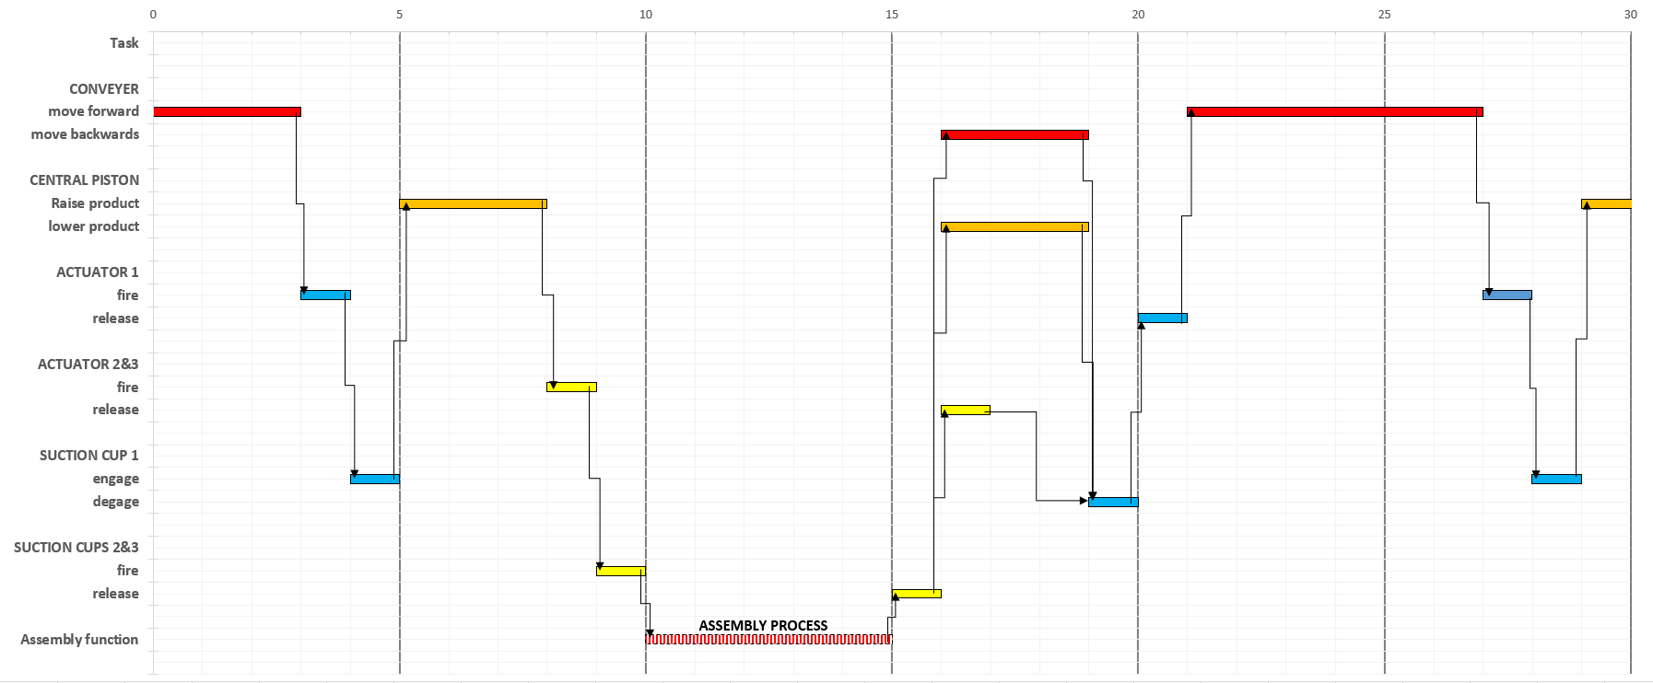

Figure 9. Time sequencing cycle diagram

###### Reconfiguration timings

The speed and ability to change the flexible fixture over for use on a different product, i.e. its flexibility.

The novel flexible fixture optimizes reconfiguration times by exploiting quick release clamps on the lower suction cups. The lower suction cup can then be adjusted in the x plane to cater for taller products.

Automatic reconfiguration is possible via servo motors and an intelligent system. Allowing the fixture to reconfigure rapidly upon new input control settings, drastically reducing line changeover times (N. Papastathis, 2018).

The only limitation with the flexible fixture is the weight capacity. Each of the flexible fixture sizes has a relative payload capacity, and a flexible product size capacity.

#### Stability & Graspability

In (Trinkle J.C. 2008) the definitions of contact behaviour between rigid bodies and dynamic kinematics are derived. End-effector to object dynamics can be conveyed through n rigid-body constraints (n of contacts) (D. Prattichizzo, 1998). For our FF system, modelled in figure 10, these constraints can be written in terms of a grasp matrix $G$ and end-effector Jacobian .

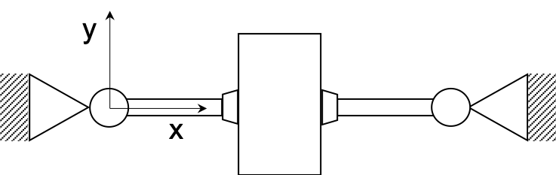

Figure 10. Manipulation system of novel flexible fixture

|  |  |  |
| --- | --- | --- |
|  | $J= \left[\begin{matrix}\begin{matrix}-1 & 0 \\ 0 & 0 \\ 0 & -1\end{matrix} \\ \begin{matrix}0 & 0\end{matrix}\end{matrix}\right]$; G $= \left[\begin{matrix}\begin{matrix}1 \\ 0\end{matrix} & \begin{matrix}0 \\ 1\end{matrix} & \begin{matrix}\begin{matrix}1 & 0\end{matrix} \\ \begin{matrix}0 & 1\end{matrix}\end{matrix} \\ 0 & -1 & \begin{matrix}0 & 1\end{matrix}\end{matrix}\right];{ G}^{T}= \left[\begin{matrix}\begin{matrix}1 \\ 0\end{matrix} & \begin{matrix}0 \\ 1\end{matrix} & \begin{matrix}0 \\ -1\end{matrix} \\ \begin{matrix}1 \\ 0\end{matrix} & \begin{matrix}0 \\ 1\end{matrix} & \begin{matrix}0 \\ 1\end{matrix}\end{matrix}\right]$ |  |
|  | $$\left[J- G^{T}\right]\left[\begin{matrix}\dot{q} \\ \dot{u}\end{matrix}\right]=0$$ | **(10)** |

The following assumptions are made:

* The transpose of the Jacobian refers to the object twist to hand frames
* When motions are slow, velocity and acceleration terms are negligible (Quasi-static assumption)
* The internal forces are only required to stay within friction coefficient
* External forces are required to move the object

Utilising the Jacobian and grasp matrices the following definitions can be made about our FF system:

1. ***Redundant:*** there exist internal motions which do not violate the contact constraints. A manipulation is said to be redundant if Ker $J ≠0$.
2. ***Determinate:*** in determinate grasp there exist motions which violate equation (A) and such the object is deemed to be firmly grasped. The simplicity of the grasp, shown in figure 10, only allows for one feasible configuration, thus the grasp is deemed to be determinate. A manipulation is also said to be kinematically *determinate* if Ker ${ G}^{T}J=0$.
3. ***Graspable:*** Graspable systems experience zero net force on the object. In literature the null spaces of $G$ are internal forces, often referred to as ‘squeezing’ forces, and are required to satisfy the materials friction coefficient. A manipulation is to be *graspable* if Ker $G≠0$. In
4. ***Defective:*** Manipulator dynamics are not affected by constraint reactions. Since ${ J}^{T} ∈R^{qxt}$, if a system has greater number t of contacts constraints than q degrees of freedom – it exhibits a defective grasp.
5. ***Non-hyperstatic:*** because ${\ker{J^{T}}}^{ }∩\ker{G=0}$ the grasp is said to be *hyperstatic.* i.e. the force and moment equilibrium conditions are sufficient to determine the internal forces and reactions on the structure.

#### FEA Method

In order to validate the theoretical results, showed in the stiffness analysis section, a finite element analysis was conducted on the model. The software used for the simulation is SOLIDWORKS, as that’s the software used to build the model in the first place, and it allows for an accurate analysis.

Assumptions

The first assumption made was to run the simulation on only half of the model. This is because the system is symmetric about the longitudinal axis, and also because the load was applied to the middle of the model.

Set up

The model was set up in order to find the highest stress and displacement that the actuator could undergo. Therefore, the simulation was set up so that the system would be holding the vice using only the central actuators.

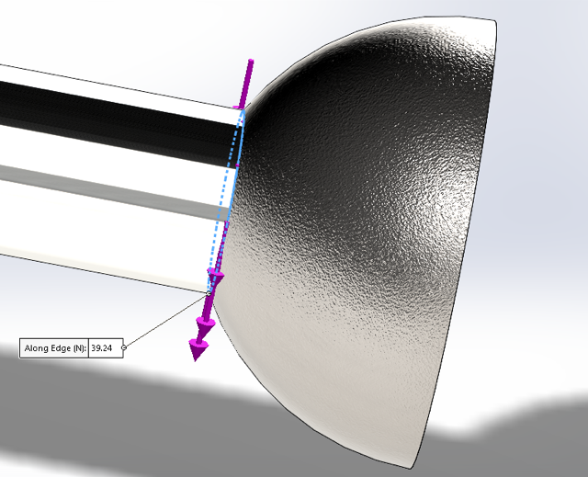

*Figure 11. Point Load applied*

The actuator was set to its maximum extension, this being of $63 mm$. The mass applied to the actuator was assumed to be of $8 kg$ for the whole system. Because the simulation was run on half of the model, the used mass was of $4 kg$. Therefore, the applied load was of $4 ×9.81\frac{m}{s^{2}}=39.24 N$. This was modelled as a point load, shown in *Figure 11*. Finally, the meshing used was the finest possible, in order to allow for accurate results.

# Results, Discussions and Conclusions

## 6.01 Results

The obtained displacement from the simulation is shown in *Figure 12-13* below. As clearly visible from *Figure 13*, the highest displacement is $1.263×{10}^{4}$ m, and it is experienced at the end of the actuator, as expected. The displacement found from the simulation is similar to the theoretical one, with an error of $4.9 \%$. The simulation also allows to certify that the model would not fail due to the excessive load. This is showed by the highest stress experienced by the structure, which is at the point of contact between the two cylindrical components of the actuator. The registered maximum stress is $2.572 MPa$, with the Yield strength being $2.413×{10}^{2}MPa$. Therefore, the system is suitable for the application.

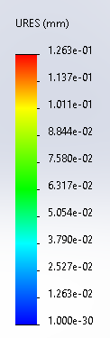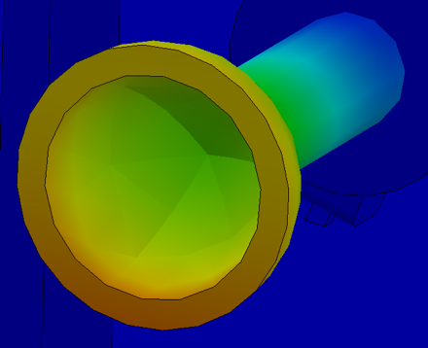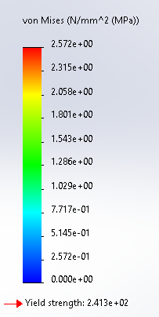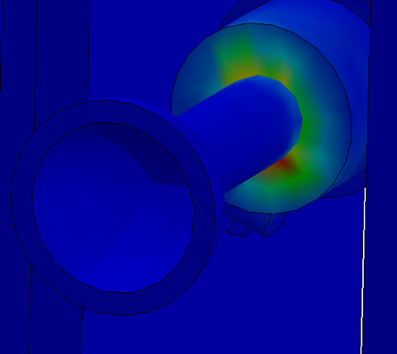

Figures 12-13. Displacement & Stress simulations on FEA

## 6.08 Discussion

#### Design altercations

*Table 2. Design Altercations*

|  |  |  |
| --- | --- | --- |
| **Design Altercation** | **Current Design Problems** | **Potential Design Solutions** |
| Work Volume | Work area currently has a limited X-Y work range of 4350mm2 - 48000mm2 (appendix Item 5). This means only workpieces with a surface area within this range can be fixed and secured. | Adapting the flexible fixture by creating a wider base so the cartesian robot can operate with a greater reach. This will mean components with bigger surface areas can be used. However, workpieces will still be restricted to a maximum weight due to actuator force limitations. |
| Suction Cup End Effector | Rubber end effector of suction cup has certain degree of flex when connecting to workpiece. This reduces the stability of the workpiece when fixed in position for assembly. | Rethink material which has a greater stiffness. Alternatively, actuators could be programmed to accommodate for flex within the end effector, moving depending on how much deformation the rubber is subject to. |
| Actuator Locations/Configurations | Current design has 6 points of contact from each side of the conveyor belt. This limits its stability and also flexibility to adapt to certain workpieces. | Having a greater number of actuators to fix the workpiece in position. Actuators can come vertically up from the floor, securing any workpiece from the bottom to add stability. |
| Workpiece Variation | Flexible fixture is limited to securing workpieces where the contact surface area is parallel to the suction cups. If a workpiece had any degree of slant on its connecting surface area, the suction cups would not be able to secure onto it. | Suction cups attached to the actuator rod on a ball/socket connector-type arrangement. This means the end effector could locate and have a flush connection with a workpiece if its surface area as not parallel with the flexible fixture (appendix item 6). |

#### Wider application of novel design

*Table 3. Wider applications of novel flexible fixture*

|  |  |  |
| --- | --- | --- |
| Wider Applications of Design | Description | |
| Workpiece Variation | Our novel flexible fixture design has the ability not just to be used in the assembly operation of a vice within a FIAB, but any workpiece that can fit within the dimensional constraints of the fixture. The actuators can move around in the X, Y, Z plane to secure workpieces of varying dimensions. | |
| End Effector Altercation | Using the flexible fixture set-up, but changing the suction cup end effector, this design can be used for a multitude of different applications: | |
|  | * Screw Insertion/Assembly * Spot Welding | * Visual Inspections * Machining |
| Sheet Material Manufacture | Similar to the aircraft industry, this novel approach to securing the vice can be used for sheet material (Torrelstool 2020). Altering the end effector locations so they are all on the same plane, this will allow sheet material to be secured in any desired location. | |

#### Future research and opportunities

*Table 4. Future research development & opportunities*

|  |  |
| --- | --- |
| **Future Research Opportunities** | **Integration into FIAB** |
| Smart Sensor Integration | Accurate force/torque control from integrating smart sensors into the flexible fixture, it will prevent the workpiece from being damaged due to excessive stresses. Industry 4.0-Ready Sensors such as Robotiq FT 300 (Robotiq, 2020) can be integrated into our flexible fixture actuators to allow for accurate stability and assembly of the vice. Being able to incorporate machine learning into the sensor, this can be used to assemble a multitude of different workpieces coming through the FIAB, ensuring the flexible fixture will not be fatigued. |
| Predictive Maintenance of Flexible Fixtures | Machine learning methods using Support Vector Machine (R. Gandhi, 2018), AI programmes will be able to monitor the flexible fixture within the FIAB and accurately predict the optimum time for maintenance. As the flexible fixture is autonomous and working remotely, implementing predictive maintenance will ensure parts such as suction cups or actuator rods can be replaced with minimised downtime. |
| FIAB Conveyor Tracking | Analysing smart conveyor systems will be the next logical step in research for the FIAB concept. Positional accuracy for our novel Flexible Fixture design is dependant not only on the actuator’s locating ability but on the conveyor system too. Specifications such as load capacity per unit length, maximum load capacity, conveyor belt speed and drive locations are all areas that will impinge on the efficiency of the FIAB system.  Smart conveyor tracking is a technology that upon further research will enable the flexible fixture to reposition itself dependant on the orientation and position of the workpiece on the conveyor. This enables the flexible fixture actuators to adjust their position from a set pre-programmed fixing location and move about depending on the workpiece (Y. Zhang et al., 2018). |
| Digital twin for Flexible Fixture | Researching the implementation of a digital twin for our novel Flexible Fixture design will allow the system to digitally replicate all sensory data outputted from the fixture. Using machine learning, this will be able to optimise the assembly process of the vice and ensure the flexible fixture is working at the required system efficiency levels. |

## Conclusion

This paper has presented the concept of a novel flexible fixture integrated with industry 4.0 and FIAB, to enhance the flexibility of a robotic workcell. The methodology proposed provides a design which is built upon the understanding of flexible fixtures in literature. Respective calculations and modelling techniques have been used to evaluate the requirements of the design, which thereafter, has been critically analysed using FEA. The wider implications and opportunities created have been discussed in detail, and further research can enable the full autonomous realization of this concept.

# References (Section 2):

[1] A. llidge, G. Bright. (2018). An Automated Flexible Fixture System for Mass Customisation. [online] Available at: [Accessed 28th November 2020]

[2] Klaus Dröder, Franz Dietrich, Christian Löchte, Jürgen Hesselbach. (2016). Model Based Design of Process-Specific Handling Tools for Workpieces With Many Variants In Shape and Material. [online] Volume 65, Issue 1,Pages 53-56. Available at: <http://www.sciencedirect.com/science/article/pii/S0007850616301093> [Accessed 28th November 2020]

[3] Hong Du, Grier C.I. Lin. (1998). Development of an Automated Flexible Fixture for Planar Objects. [online] Volume 14, Issue 3, Pages 173-183. Available at: <http://www.sciencedirect.com/science/article/pii/S0736584598000040> [Accessed 20th November 2020]

[4] MONKA, P.P., MONKOVA, K., JAHNÁTEK, A. and VANCA, J. (2021). Flexible manufacturing system simulation and optimization. [online] Pages 53-65. Available at: https://link.springer.com/chapter/10.1007/978-3-030-58362-0_4 [Accessed 28th November 2020]

[5] Gothwal Suman & Raj Tilak. (2017). Different aspects in design and development of flexible fixtures: review and future directions. International Journal of Services and Operations Management. 26. [online] Available at: <https://www.researchgate.net/publication/313252944> [Accessed 28th November 2020]

[6] Erdem, Ilker & Asbjornsson, Gauti & Kihlman, Henrik. (2020). Workpiece force and position control for active and flexible fixtures in assembly. The International Journal of Advanced Manufacturing Technology. [online] Available at: <https://www.researchgate.net/publication/346031321> [Accessed 28th November 2020]

[7] Fan, Wei & Zheng, Lianyu & Wang, Yahui. (2018). An automated reconfigurable flexible fixture for aerospace pipeline assembly before welding. [online] Available at: <https://www.researchgate.net/publication/325480322> [Accessed 28th November 2020]

[8] Otto Jan Bakker, Thomas N. Papastathis, Svetan M. Ratchev and Atanas A. Popov. (2013). Recent Research on Flexible Fixtures for Manufacturing Processes. [online] Volume 6, Issue 2. Available at: <https://www.researchgate.net/publication/259042043> [Accessed 28th November 2020]

[9] Vitalii Ivanov, Ivan Dehtiarov, Jozef Zajac. (2018). Flexible Fixtures for Parts Machining in Automobile Industry. [online] Available at: [https://eudl.eu/doi/10.4108/eai.22-11-2017.2274155](https://eudl.eu/doi/10.4108/eai.22-11-2017.2274) [Accessed 28th November 2020]

[10] Singholi, A., Ali, M. and Sharma, C. (2013) ‘Evaluating the effect of machine and routing flexibility on flexible manufacturing system performance’, International Journal of Services and Operations Management, Vol. 16, No. 2, pp.240–261. [online] Available at: [Accessed 3rd December 2020]

[11] Bakker, O.J., Papastathis, T.N., Popov, A.A. and Ratchev, S.M. (2012) ‘Active fixturing: literatur review and future research directions’, International Journal of Production Research, Vol. 51, No. 11, pp.1–20. [onine] Available at: [Accessed 3rd December 2020]

[12] Bi, Z.M. and Zhang, W.J. (2001) ‘Flexible fixture design and automation: review, issues and future direction’, International Journal of Production Research, Vol. 39, No. 13, pp.2867–2894. [online] Available at: [Accessed 3rd December 2020]

[13] De Leonardo L, Zoppi M, Xiong L, Zlatanov D, Molfino RM. (2013). SwarmItFIX: a multi-robot-based reconfigurable fixture. Pp.320–328. [online] Available at: [Accessed 2nd December 2020]

[14] McKeown C, Webb P. (2011). A reactive reconfigurable tool for aerospace structures. Assem Autom 31(4) pp. 334-343. [online] Available at: [Accessed 2nd December 2020]

[15] Fantoni, G., Santochi, M., Dini, G., Tracht, K., Scholz-Reiter, B., Fleischer, J., Kristoffer Lien, T., Seliger, G., Reinhart, G., Franke, J., Nørgaard Hansen, H., & Verl, A. (2014). Grasping devices and methods in automated production processes. CIRP Annals, 63(2), 679–701. <https://doi.org/10.1016/j.cirp.2014.05.006>

[16] Tichem, M., Lang, D., & Karpuschewski, B. (2004). A classification scheme for quantitative analysis of micro‐grip principles. Assembly Automation, 24(1), 88–93. <https://doi.org/10.1108/01445150410698976>

[17] Schmalz, J., Giering, L., Hölzle, M., Huber, N., & Reinhart, G. (2016). Method for the Automated Dimensioning of Gripper Systems. Procedia CIRP, 44, 239–244. <https://doi.org/10.1016/j.procir.2016.02.106>

[18] Mandaná Moshiri, Amal Charles, Ahmed Elkaseer, Steffen Scholz, Sankhya Mohanty, Guido Tosello, An Industry 4.0 framework for tooling production using metal additive manufacturing-based first-time-right smart manufacturing system, Procedia CIRP, Volume 93, 2020, Pages 32-37,

[19] Shohin Aheleroff, Xun Xu, Yuqian Lu, Mauricio Aristizabal, Juan Pablo Velásquez, Benjamin Joa, Yesid Valencia, IoT-enabled smart appliances under industry 4.0: A case study, Advanced Engineering Informatics, Volume 43, 2020, 101043, ISSN 1474-0346,

[20]Engineersedge.com. 2020. Coefficient Of Friction Equation And Table Chart - Engineers Edge. [online] Available at: <https://www.engineersedge.com/coeffients_of_friction.htm> [Accessed 4 December 2020].

[21]Actuator EGSL-BS-35-50-8P | EGSL-BS-35-50-8P mini slide | RS Components (2020). Available at: https://uk.rs-online.com/web/p/electric-actuators-rod/2029677/ (Accessed: 12 December 2020).

[22] Giuseppe Dalla Costa, Gianfranco Genta, Giulio Barbato, Leonardo De Chiffre, Hans Norgaard Hansen, Accuracy Assessment of an Industrial Actuator, Procedia CIRP,

Volume 62, 2017, Pages 417-422,

[23] Letourneau, R., 2019. What Are The Best Types Of Cups For Your Workpiece?. [online] Blog.robotiq.com. Available at: <https://blog.robotiq.com/what-are-the-best-types-of-cups-for-your-workpiece> [Accessed 6 December 2020].

[24] Festo.com. 2006. [online] Available at: <https://www.festo.com/net/SupportPortal/Files/17068/Poster_VacuumGripping_en.pdf> [Accessed 6 December 2020].

[25] Jaiswal, A.K. and Kumar, B., VACUUM GRIPPER-AN IMPORTANT MATERIAL HANDLING TOOL. International Journal of Science & Technology, 7(1).

[26] Marco Ryll, Thomas N. Papastathis, Svetan Ratchev, Towards an intelligent fixturing system with rapid reconfiguration and part positioning, Journal of Materials Processing Technology, Volume 201, Issues 1–3,

[27] Prattichizzo D., Trinkle J.C. (2008) Grasping. In: Siciliano B., Khatib O. (eds) Springer Handbook of Robotics. Springer, Berlin, Heidelberg. <https://doi.org/10.1007/978-3-540-30301-5_29>

[28] D. Prattichizzo and A. Bicchi, "Dynamic analysis of mobility and graspability of general manipulation systems," in IEEE Transactions on Robotics and Automation, vol. 14, no. 2, pp. 241-258, April 1998, doi: 10.1109/70.681243.

[29] Torrelstool (2020). Multiflexible Universal Holding Fixture. [online] Available at: <https://www.mtorres.es/en/aeronautics/products/metallic/torrestool> [Accessed 13th December 2020]

[30] ROBOTIQ 2020, FT 300 Force Torque Sensor. [online] Available at: <https://robotiq.com/?ref=nav_product_new_button> [Accessed 10th December 2020]

[31] Rohith Gandhi, 2018. Support Vector Machine – Introduction to Machine Learning Algorithms. [online] Available at: <https://towardsdatascience.com/support-vector-machine-introduction-to-machine-learning-algorithms-934a444fca47> [Accessed 10th December 2020]

[32] Y. Zhang, L. Li, M. Ripperger, J. Nicho, M. Veeraraghavan, A. Fumagalli, (2018). Gilbreth: A Conveyor-Belt Based Pick-and-Sort Industrial Robotics Application. [online] Available at: <https://ieeexplore.ieee.org/document/8329876> [Accessed 10th December 2020]

# Appendix (Section 2):

ITEM 1

#### Exploded view

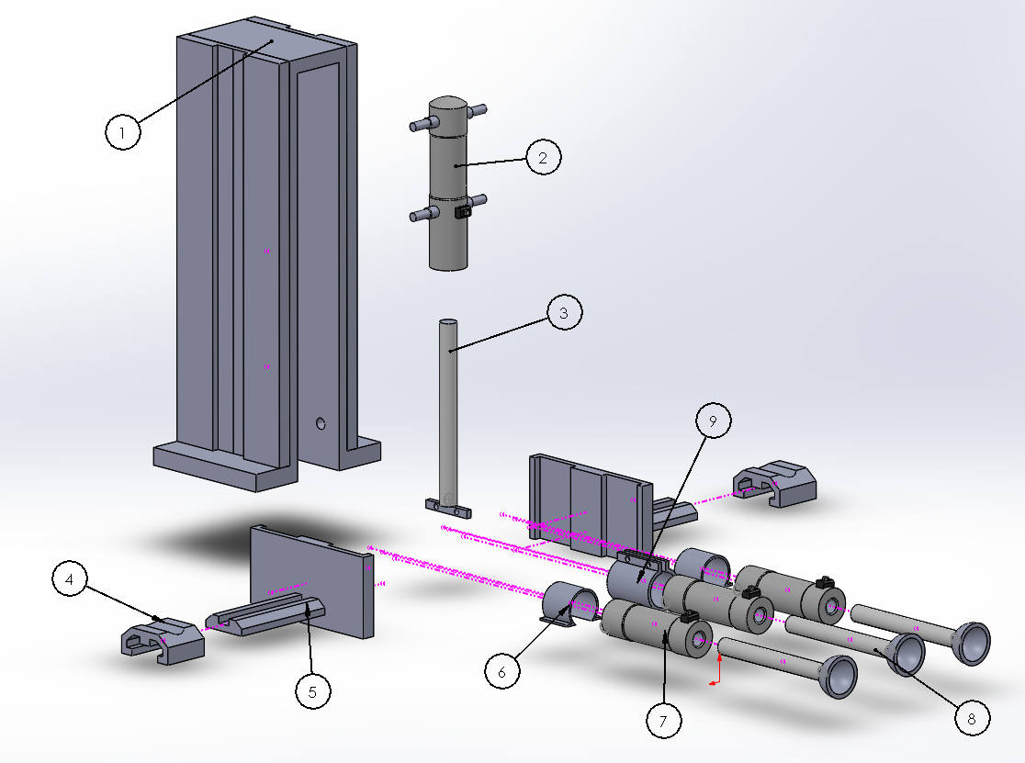

Figure 5. Exploded view of novel Flexible Fixture

ITEM 2

#### Bill of materials

*Table 1. Bill of Materials*

|  |  |  |  |
| --- | --- | --- | --- |
| **BALLOON NO.** | **PART NUMBER** | **DESCRIPTION** | **QTY** |
| **1** | **Part 1** | **Fixture** | **1** |
| **2** | **Part 2** | **Y Lock pipe** | **1** |
| **3** | **Part 3** | **Central Piston** | **1** |
| **4** | **Part 4** | **XY Slide** | **2** |
| **5** | **Part 5** | **Sliding Z component** | **2** |
| **6** | **Part 6** | **XY Clamp** | **2** |
| **7** | **Part 7** | **XY Lock pipe** | **3** |
| **8** | **Part 8** | **Suction cups** | **3** |
| **9** | **Part 9** | **Centre clamp** | **1** |
| **-** | **Part 10** | **M4 bolts** | **12** |
| **-** | **Part 11** | **M4 washers** | **12** |
| **-** | **Part 12** | **M4 nuts** | **12** |
| **-** | **Part 13** | **M6 bolts** | **8** |
| **-** | **Part 14** | **M6 washers** | **8** |
| **-** | **Part 15** | **M6 nuts** | **8** |

ITEM 3. Operational sequence plan

Our novel approach to an innovative idea of a flexible fixture is designed to be implemented into a conveyor assembly sequence. Used to fix, locate and support workpieces for assembly, the flexible fixture can be adapted to many workpieces of varying sizes and geometries. The operational sequence of the flexible fixture for a vice within a FIAB is as follows:  
1 - Vice makes its way along a conveyor belt to position itself adjacent to the flexible fixture. Locating sensors will ensure it stops in the correct position for the suction cups to locate and fix accurately onto the vice (a).  
2- The middle actuators locate the vice from either side and grips it with sufficient force so that it can securely fasten it (b).  
3- The middle actuators can both move linearly in the z-plane and rotate around their own axis. Once suitably clamped, the middle actuator rises up whilst rotating. This puts the workpiece, in this case the vice, at a 90-degree angle. The vice is at this angle as it makes assembly far easier for the robots (c).  
4- Once in the vertical position, the bottom two actuators on either side grip onto the vice to add to stability. As these actuators are on a cartesian-styled electronic mounting rail, they can be adjusted to the geometry of the workpiece. It is at this point that the assembly sequence of the vice can begin to take place (d).

ITEM 4. (A-D)

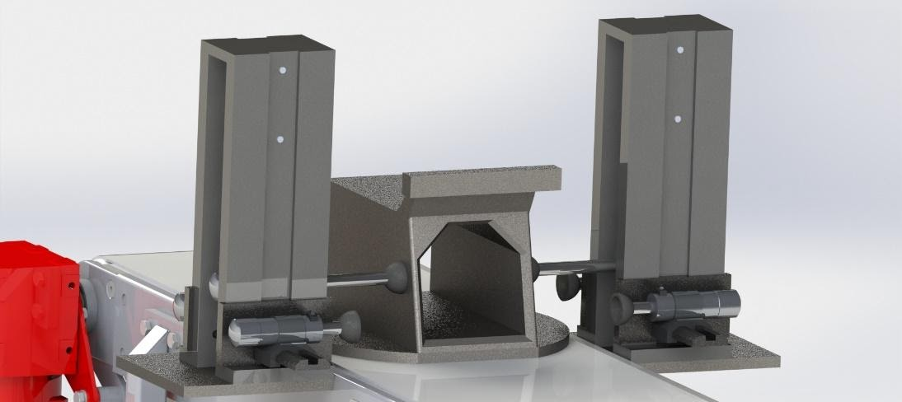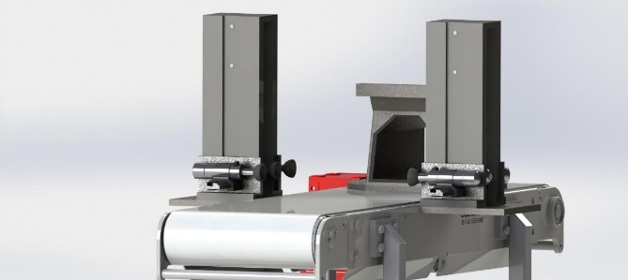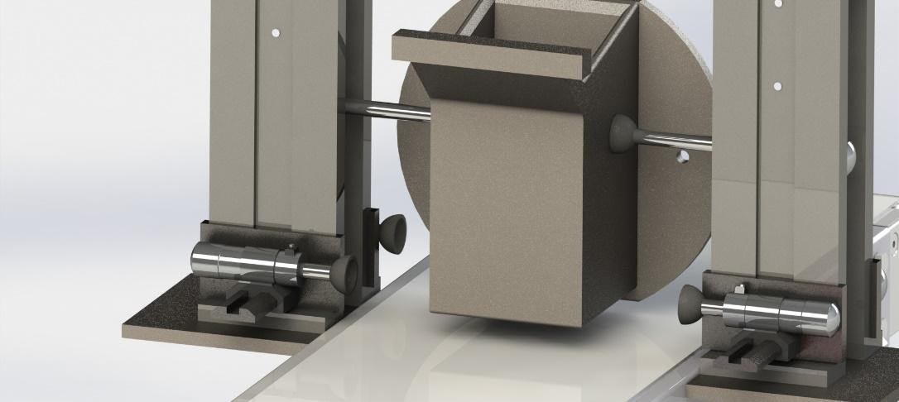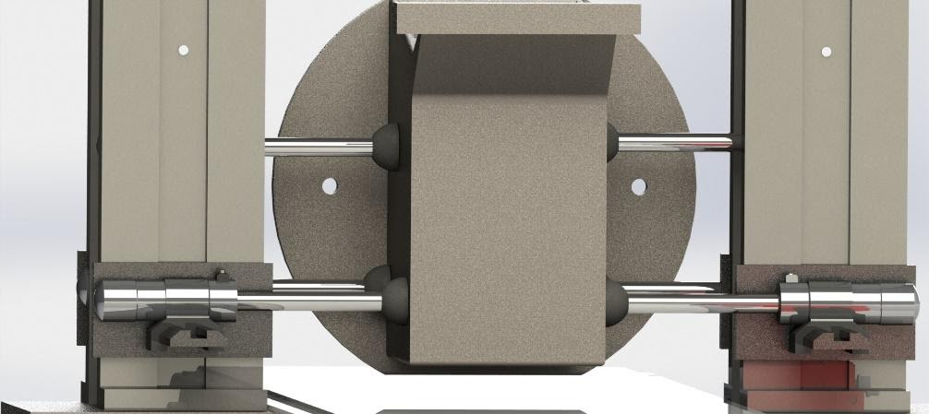

(a)

(b)

(c)

(d)

ITEM 5. A & B

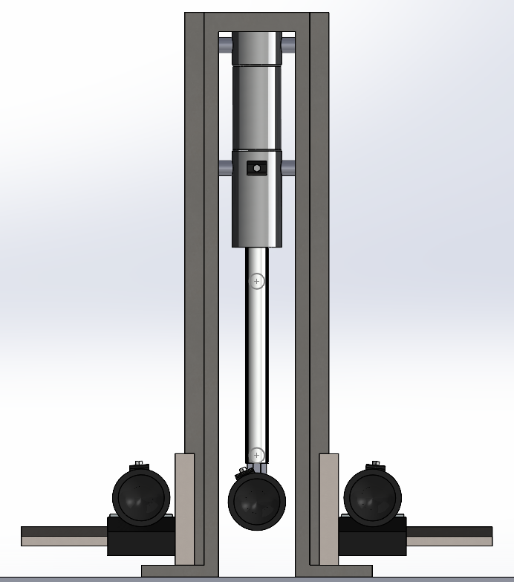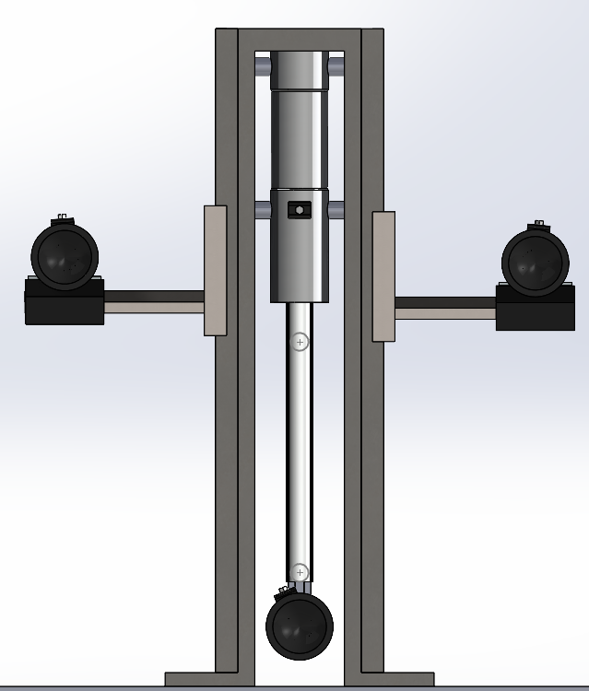

200mm

240mm

145mm

30mm

ITEM 6.

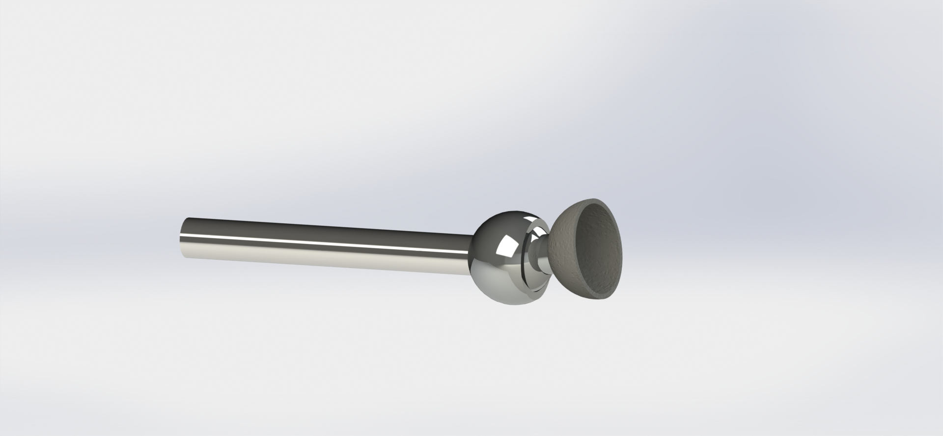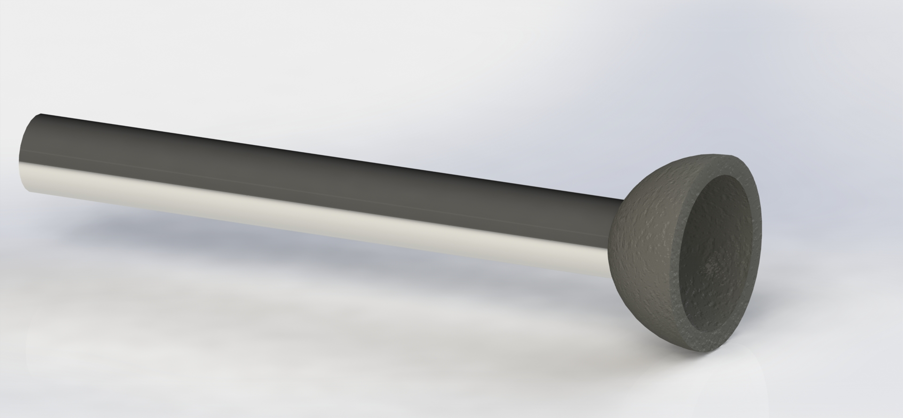

Section 3

# Feedback

* Enjoyed the two separate sections (i.e. the content-based weeks 1-6 and the research project-based work) was refreshing to split the term in this manner.
* Style of lectures was good, enjoyed zoom call lectures, even with the difficulties that came with remote communication.
* Work load was challenging - especially due to remote working, yet still manageable.
* Consensus is very happy with the module content and presentation, and very appreciative of the time and effort put in by the academics.